**INTRODUCTION TO HTML**

**FORMS AND CSS BASICS**

**LAB # 09**



**Fall 2021**

**CSE101L Computer Fundamentals Lab**

Submitted by: **Ali Asghar**

Registration No. :21PWCSE2059

Class Section: **C**

“On my honor, as student of University of Engineering and Technology, I have neither given nor received unauthorized assistance on this academic work.”



Student Signature: ______________

Submitted to:

**Engr. Abdullah Hamid**

March 12, 2022

Department of Computer Systems Engineering

University of Engineering and Technology, Peshawar

**LAB TASKS**

**Task 1:**

Make a webpage according to the diagram in the image below

NOTE: Your page must have a background (color or image), also your page font should be courier, font color should be any color matching your background (not black default font color) and everything on the page should aligned to the center, all this should be done through CSS (internal only). Also you must use “CLASS SELECTORS” in CSS.

This Lab task should be uploaded as an HTML FILE. The Picture(s) (if you have used any) should also be uploaded so that I could check it properly.

**CODE SCREENSHOT:**

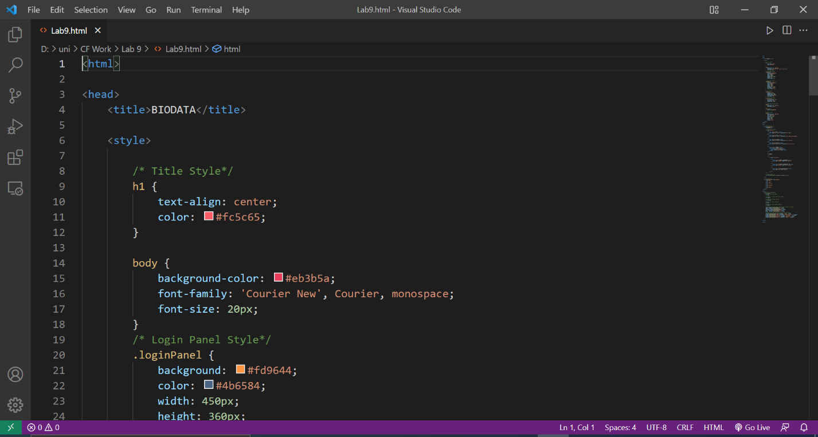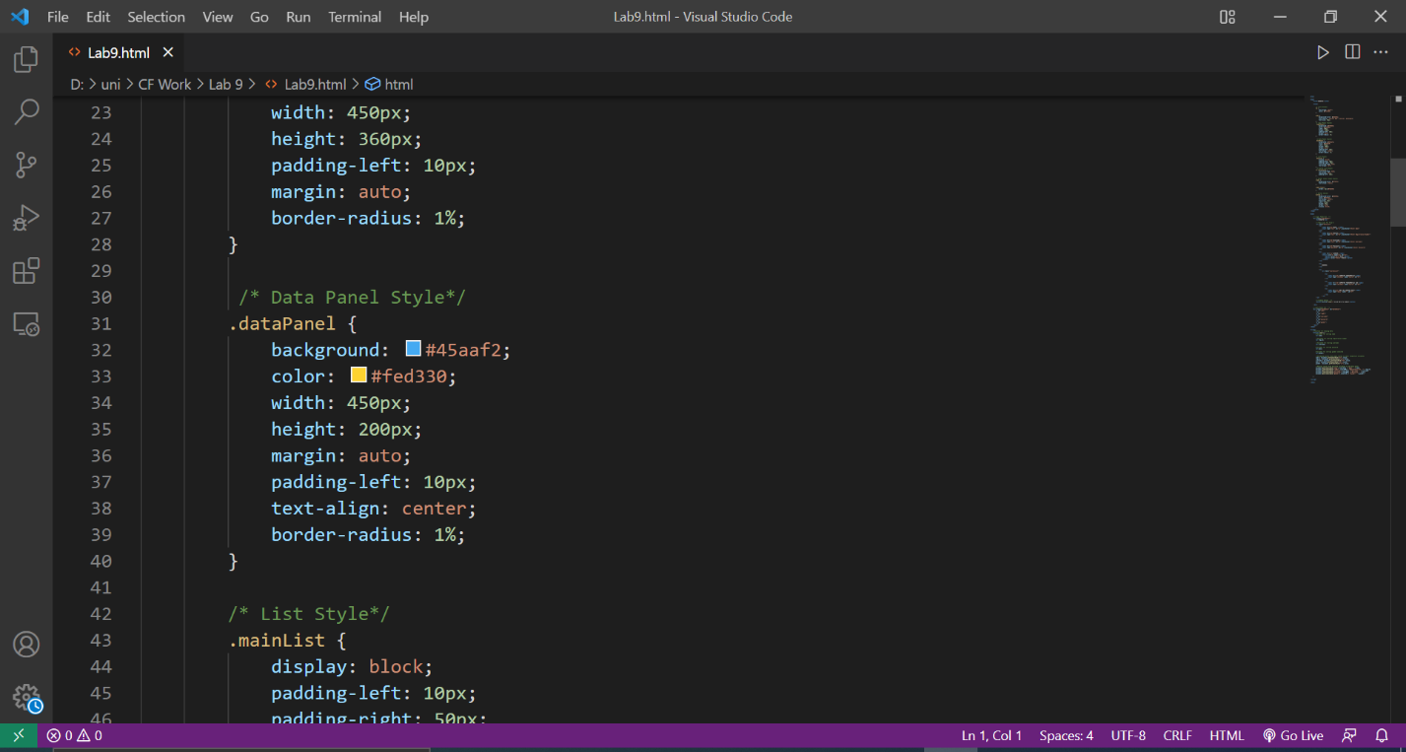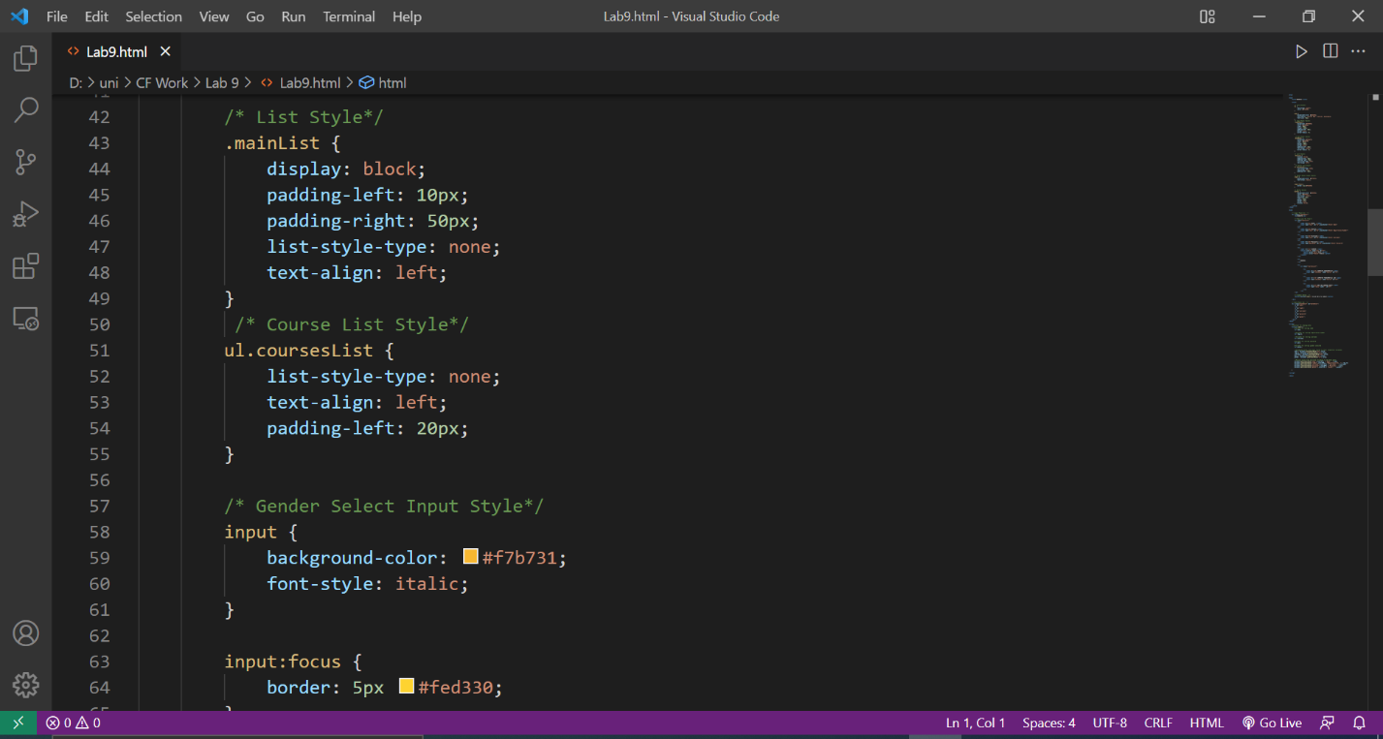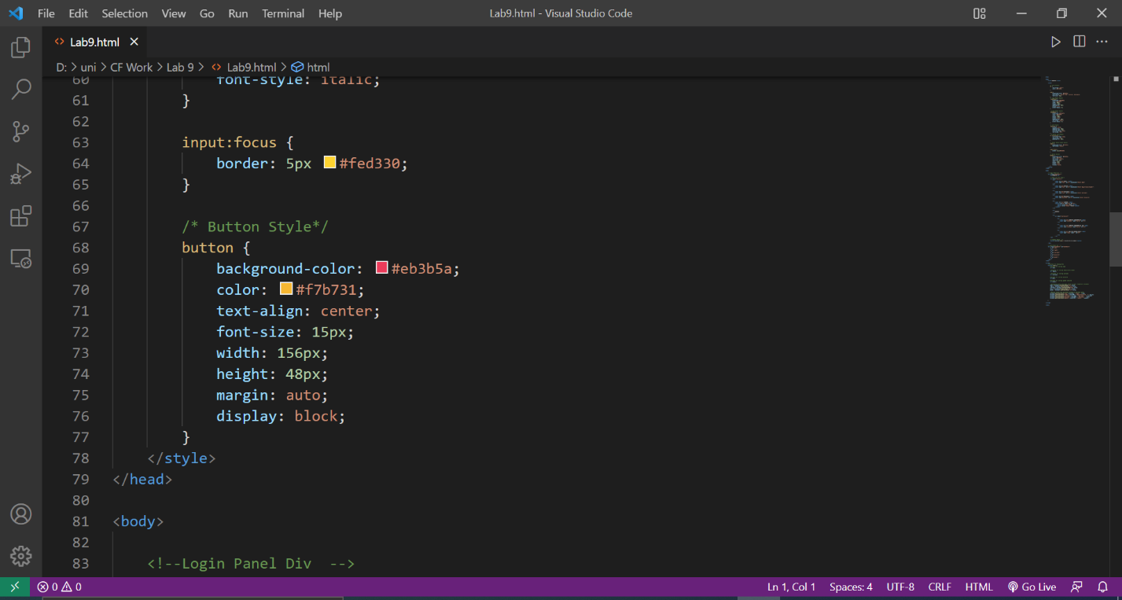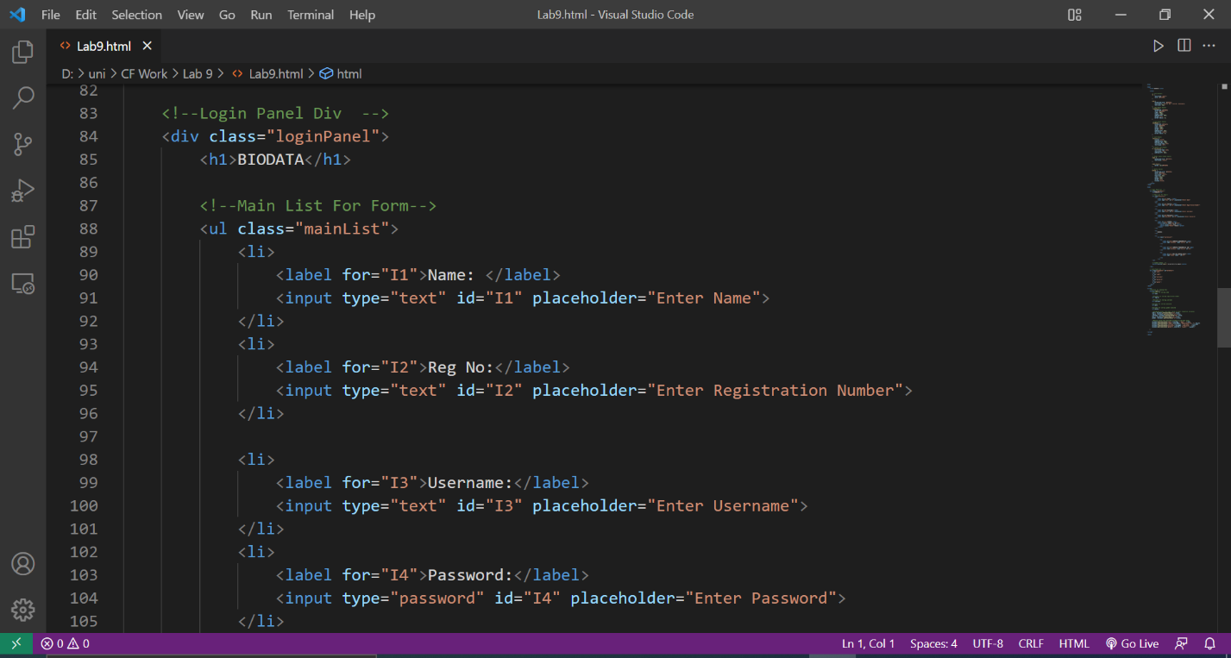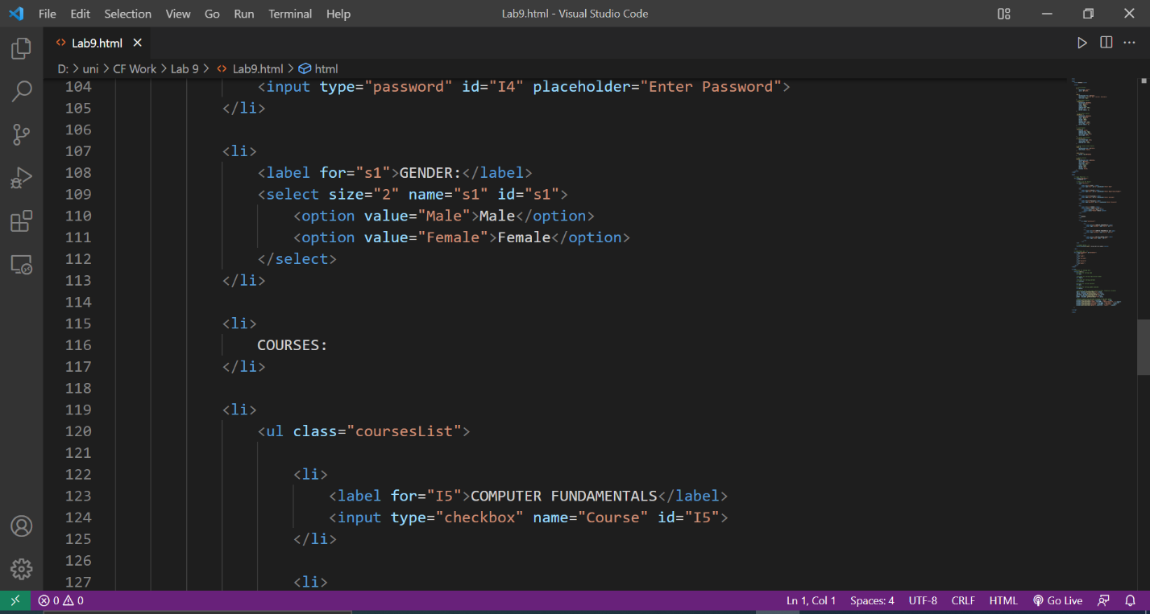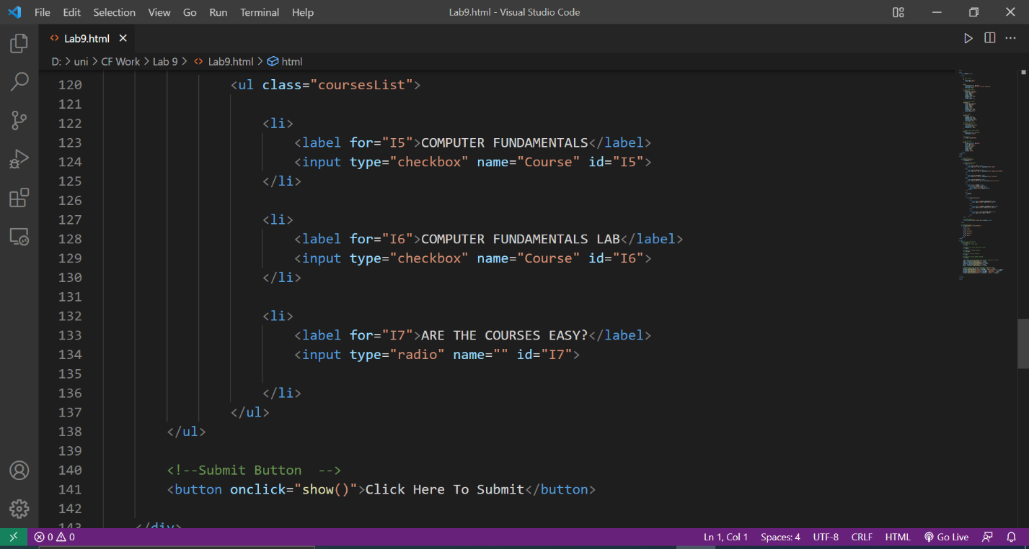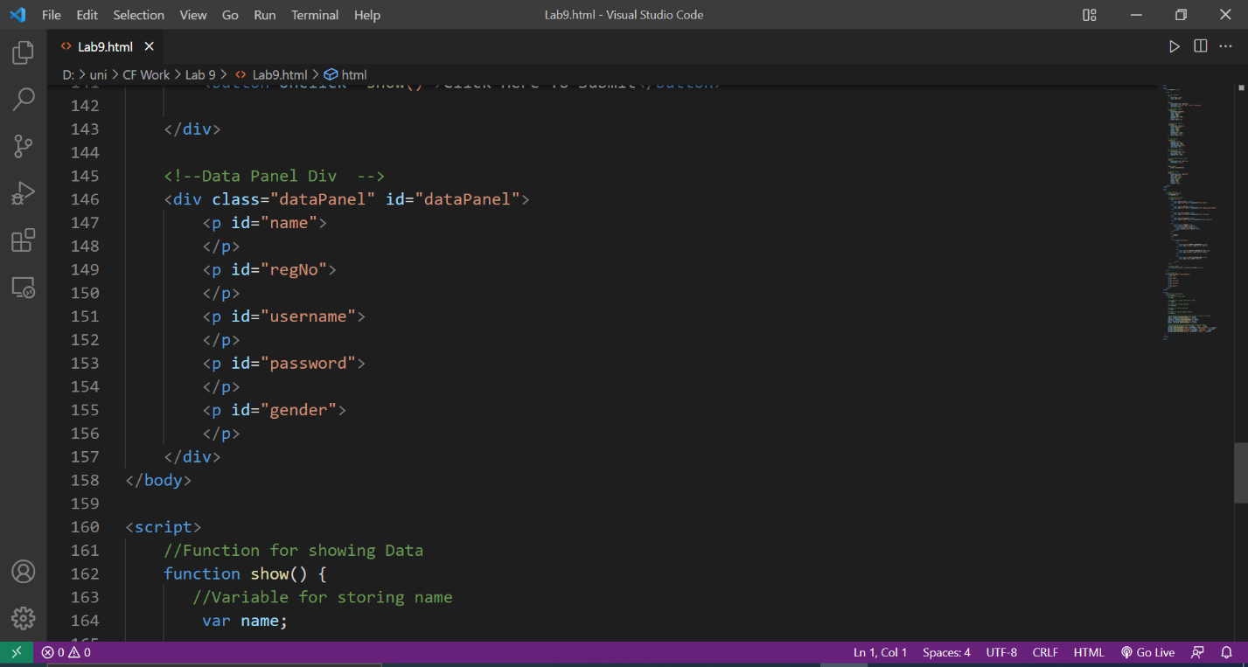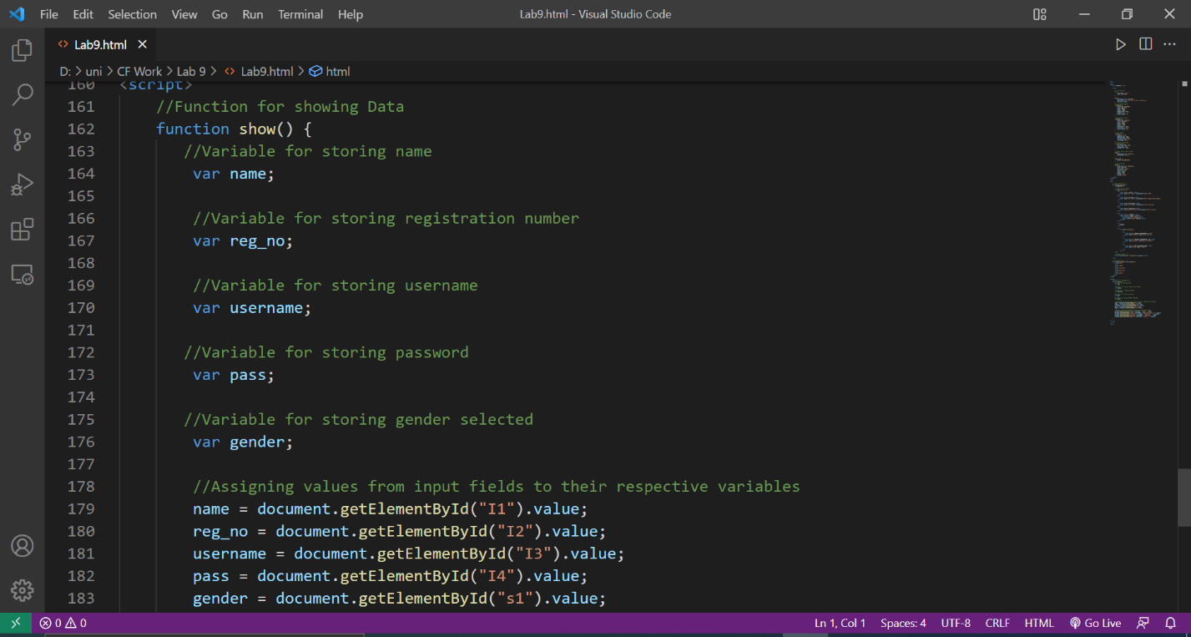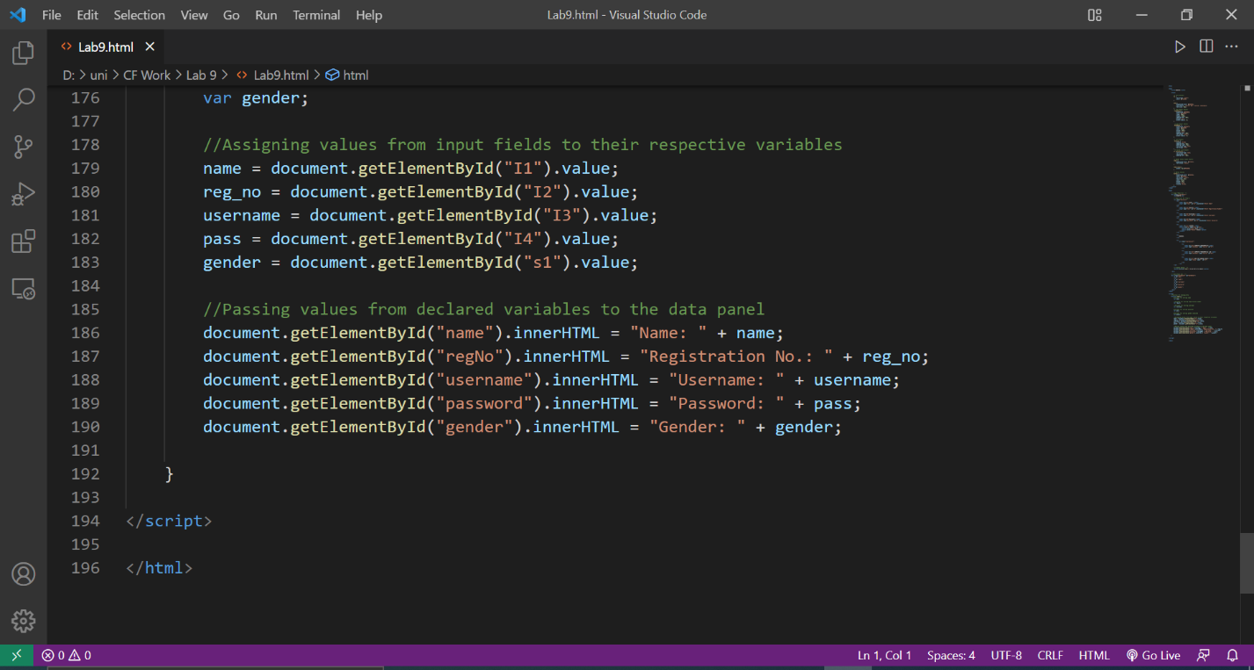**OUTPUT:**